**URS & SRS**

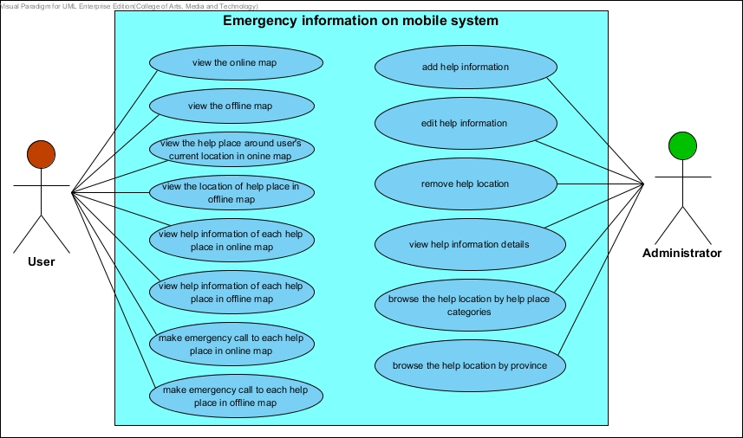

**• Feature 5:** Manage Information System

**[URS-1]: The administrator can add help information, which includes name, address, district, province, zip code, phone number, category, latitude and longitude.**

SRS-1: The system provides the UI, which receive name, address, district, province, zip code, phone number, category, latitude and longitude.

SRS-2: The system provides map UI.

SRS- : The system shall receive latitude and longitude from map.

SRS-3: The system shall check the name length. The name must be 1- 50 characters.

SRS-4: The system shall check the address length. The address must be 0- 20 characters.

SRS-5: The system shall check the district length. The district must be 0- 20 characters.

SRS-6: The system shall check the district length. The district must be 0- 20 characters.

SRS-7: The system shall check the province length. The province must be 1- 20 characters.

SRS-8: The system shall check the zip code length. The zip code must be 0-5 characters.

SRS-9: The system shall check the phone number format. The phone number should be 9-10 digits.

SRS-10: The system shall check the latitude format. The format must be decimal number of degrees. The latitude format must not be empty.

SRS-11: The system shall check the longitude format. The format must be decimal number of degrees. The latitude format must not be empty.

SRS-12: The system shall add a new help location into the database.

SRS-13: The system shall provide the successful adding help information UI.

SRS-14: The system shall display the error message “Incorrect information, please input again”

**[URS-2]: The administrator can edit help information, which includes name, address, district, province, zip code, phone number, category, and coordinates location.**

SRS-: The system shall retrieve the help information from system database.

SRS-: The system shows information of the selected help place.

SRS-: The system shall provide edit UI.

SRS-1: The system provides the UI, which receive name, address, district, province, zip code, phone number, category, latitude and longitude.

SRS-2: The system provides map UI.

SRS- : The system shall receive latitude and longitude from map.

SRS-3: The system shall check the name length. The name must be 1- 50 characters.

SRS-4: The system shall check the address length. The address must be 0- 20 characters.

SRS-5: The system shall check the district length. The district must be 0- 20 characters.

SRS-6: The system shall check the district length. The district must be 0- 20 characters.

SRS-7: The system shall check the province length. The province must be 1- 20 characters.

SRS-8: The system shall check the zip code length. The zip code must be 0-5 characters.

SRS-9: The system shall check the phone number format. The phone number should be 9-10 digits.

SRS-10: The system shall check the latitude format. The format must be decimal number of degrees. The latitude format must not be empty.

SRS-11: The system shall check the longitude format. The format must be decimal number of degrees. The latitude format must not be empty.

SRS-: The system shall update the help information into the database.

SRS-: The system shall provide the successful editing help information UI.

SRS-14: The system shall display the error message “Incorrect information, please input again”

**[URS-3]: The administrator can remove help location.**

SRS-: The system shall retrieve the help information from system database.

SRS-: The system shall provide UI to show all lists of help locations.

SRS-: The system shall provide remove UI.

SRS-: The system shall provide UI with message “Are you sure to delete?” to ask permission before remove help place.

SRS-: The system shall delete the help place out of the database.

SRS-: The system shall provide the successful removing help place UI.

**[URS-4]: The admin can view help information of each help place.**

SRS-: The system shall retrieve the help information from system database.

SRS-: The system shall provide UI to show all lists of help locations.

SRS-: The system retrieves information of the selected help place from database.

SRS-: The system shall show the help information, which includes name, address, district, province, zip code, phone number, category, latitude and longitude

**[URS-5]: The administrator can browse the help location by help place category.**

SRS:-The system provides the categories UI, which are police station, highway police station, hospital, and garage.

SRS:-The system shall retrieve the help information from database by the selected category.

SRS:-The system shall show the list of help location by selected category.

**[URS-6]: The administrator can browse the help location by province of Thailand.**

SRS-: The system provides UI to show list province of Thailand

SRS-: The system shall retrieve the help information from database by the selected province.

SRS-: The system shall show the list of help location by selected province.

**• Feature 1:** Map and Help Information System

**[URS-7]: The user can view the online map with their current location.**

SRS-: The system shall obtain the latitude and longitude of the user’s current location.

SRS-: The system shall show the online map UI.

SRS-: The system shall show the user’s current location on the online map.

**[URS-8]: The user can view the offline map with their current location.**

SRS-: The system shall obtain the latitude and longitude of the user’s current location.

SRS-: The system shall show the offline map UI.

SRS-: The system shall show the user’s current location on the offline map.

**[URS-9]: The user can view the help places around user’s current location in online map.**

SRS-: The system shall obtain the latitude and longitude of the user’s current location.

SRS-: The system shall search latitude and longitude of help place, where locate around the user’s current location.

SRS-: The system shall show the online map UI.

*SRS-: The system shall pin help location on the online map UI.

*SRS-: The system provides the pinning of the help place onthe online map UI.

**[URS-10]: The user can view the location of help places in offline map.**

SRS-: The system shall retrieve the loaded help information from the user’s device.

SRS-: The system shall show the offline map UI.

*SRS-: The system pins help location on the offline map UI.

*SRS-: The system provides the pinning of the help place onthe offline map UI.

**[URS-11]: The user can view help information of each help place in online map.**

SRS-: The system shall retrieve the help information from system database.

SRS-: The system provides information UI to show the help information, which are name, address, district, province, zip code, and phone number.

**[URS-12]: The user can view help information of each help place in offline map.**

SRS-: The system shall retrieve the loaded help information from the user’s device.

SRS-: The system provides information UI to show the help information, which are name, address, district, province, zip code, and phone number.

**[URS-13]: The user can make emergency call to each help place .**

SRS-: The system shall provide the call UI.

SRS-: The system shall call to the selected help place.

**[URS-14]: The user can make emergency call to each help place.**

SRS-: The system shall retrieve the loaded help information from the user’s device.

SRS-: The system shall provide the call UI.

SRS-: The system call to the selected help place.